Blood Bank Management System Using Android Application

Snehasish Banik **,** Sriyansh Ghosh , TV Poonam , Prof. Laxmi Jayannavar

Department of **Computer Science & Engineering Reva University.**

Bangalore 560064, India

Email id- [rana2013.banik@gmail.com, hsriyanshghosh2000@gmail.com,](mailto:rana2013.banik@gmail.com) [tvpoonam2000@gmail.com,](mailto:tvpoonam2000@gmail.com) [laxmijayannavar@reva.edu.in](mailto:laxmijayannavar@reva.edu.in)

# *Abstract*—Availability of blood throughout emergencies is strong vital for each single object. There is a number of online blood donation centers uniting area for efficient contact between them and medical facilities. None of the net blood donation center offers immediate contact between both the donor and them. This may be the big downside of the new framework. The present bridges area unit fastidious; required additional job and large ticket. This paper provides a link between the current bank system and the improved performance structure. The current concerns might grow the effectualness of recent blood banks and facilitate new standard desktop framework to moveable framework. The proposed research each addresses the elements of expanded structure in different ways, such as the details being retained, knowledge provided and obtained by the individuals for potential projects such as relatively blood teams.

***Keywords— Blood Bank Management System (BBMS); Blood bank; donor; acceptors; administrator***

1. **INTRODUCTION**

The "Blood donation center management program" was developed to alleviate the problems learned in the manual process for rehearsing. This drug is sponsored to eliminate and regularly diminish the burdens that this new system looks like. This structure is often meant for the organization's unique need to do operations in a seamless and viable manner. Nonetheless, the code is reduced as planned to keep away from errors when entering the information[1]. It additionally gives mistake message while entering invalid information. The consumer does not need traditional knowledge to use this platform. In that what it shows in these lines is simple to grasp. Blood donation center management system will prompt error free, safe, reliable[2-4].

It will help the client concentrate on their multiple tasks, rather than the record keeping. Each group, whether big or tiny, has difficulties in maintaining and coping with data from Blood Collection, Blood Supply, Blood Inventory, Report, Blood Cell in order to allow efficient usage of resources[5-6]. Blood Bank Management Scheme has distinctive needs for Blood Bank, thus structuring restrictive representative administrative systems that are tailored to the administrative preconditions[7]. It is designed to assist with crucial plans, which will help you insure that your organization is equipped with the appropriate degree of details which subtleties for your potential goals[8-10]. Likewise, our frameworks follow remote access highlights for those busy officials who are frequently in a rush, which will enable you to manage your employees reliably whenever appropriate[11-13]. At last, these structures would empower you to manage assets all the more possibly.

1. **BLOOD BANK MANAGEMENT SYSTEM FRAMEWORK**

Blood is vital because in terms of circumstances selection it saves multiple lives all over the world. The computer architecture of the blood donation center system is database based. Web management and mobile governance allow use of cloud servers. Structure consists of:

Online Policies: Internet administrators were used to browse the web for the user.

Versatile administrations: Mobile administrations used to look through the contributor via portable application.

Database: Database is used by applications. Websevices and compact administrators used much of the data. Adequate Contributor and Acceptor upgrade is needed.

Client: The patient / acceptor is the main customer in the System layout. Contributor data is retrieved at any stage required / required by understanding / acceptor.

A blood distribution system is essentially a location where it takes care of the stored blood and the blood things. The critical aim of E-blood arrangement is to bring all of the state's blood get-togethers into a common system, support, collect and transmit complex live details and knowledge through count development. Such structure can gather all of the data of each and every person into clear reportings to Help critical authority from realistic manufacturer inspection to complete in-field blood dispersal. The details on the measuring contraptions will support the general society with some easy access to the status of blood accessibility in the system to the degree that a request may be produced or an actual sum of blood in the vicinity of the blood donation center can be reported save a beneficial life. Blood is considered as a basic point of view that oversees life. The term blood gift focus suggests a spot where the set aside blood is genuinely attempted to lessen the peril of transfusion events.

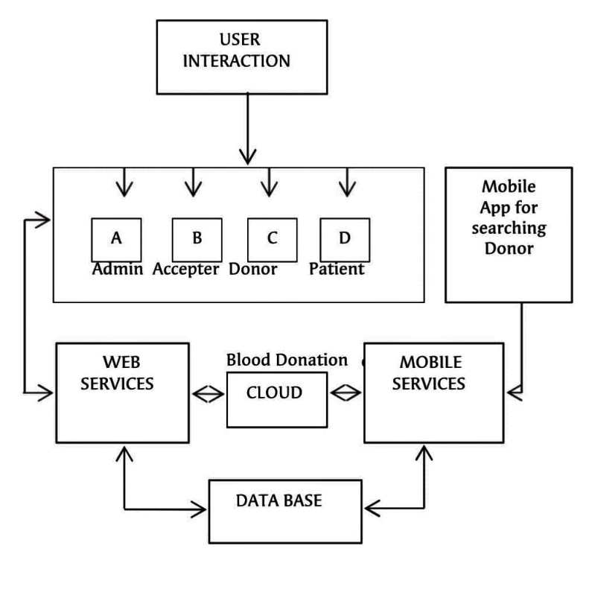

Fig 1. Blood Bank Management System Framework

The new emphasis on blood gifts allows providers unparalleled ID to track sponsor documents and retrieve details from the donor if desired in the future. This approach is especially monotonous provided that time is a fundamental consideration in view of the fast transient existence of blood and that certain situations need blood within less time in the midst of these circumstances. In addition, the documents are held in enormous storage.

1. **ANDROID APPLICATION LAYOUT**

The structure of this system for the management of blood donation centers appears in Fig 2. Data Manager blood donation center technology is rendered using Android studio.

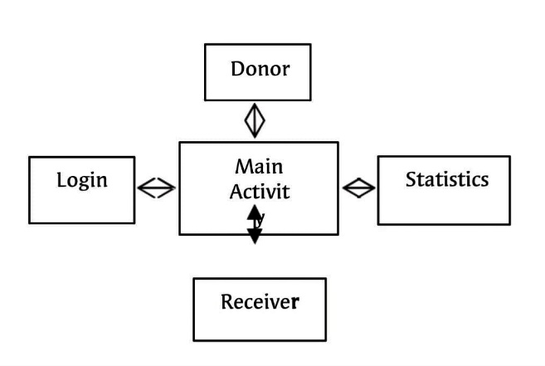

Fig 2. Blood Bank Management System Layout

Our specification contains highlights such as Sender Type, Recipient Sort, Transfers, Data, Blood Group and that's just the tip of the iceberg (Fig.3). This can require clients to select and report a particular selection of blood. This program must allow for the usability of a specific.

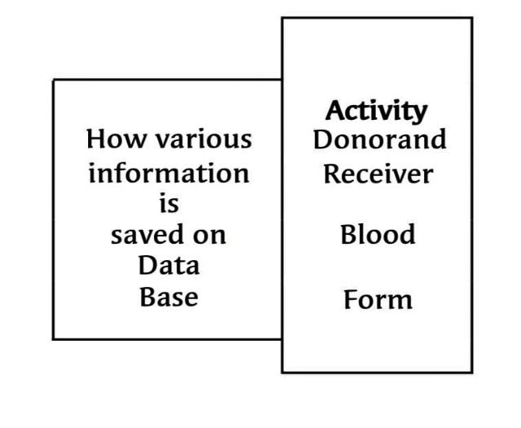

Fig 3. Application Recall and Operation in Blood Donation Management Program.

To make the most of the Android, one must have the freedom to refactor and expand their apps in order to allow maximum use of the simple and creative resources that make a difference to Android lab. It allows the programmers, for example, to create, guide and implement their projects, designing and illustrating beguilements. With the aforementioned findings it may very well be gathered that the operation of digital blood donation centers has an incredible infinite area and has tremendous maximum power and capacity in the area of resources and representation. The implementation of the technology system for the blood donation center has been successfully completed and implemented.

1. **ALGORITHM OF THE IMPLEMENTED BLOOD**

**BANK APPLICATION**

The consequence of this procedure is blood donor center note and response. The main blood donor service should provide a blood packets test database for the different stocks of blood. In the event that any of the tally goes low, the

If some of the count go down, the system would alert the specialists and a blood camp could be worked out to address the blood shortage. Likewise, the littler blood donation center will operate with a similar manner, precisely where there is a deficit the national bank would be informed and the blood will be made available. The estimate of the study being suggested is discussed below. The Details I and P references are character form.

Important changes are -

Level 1: When User is authorized, include User Id (I) and Secret Key (P) to build a new record;

Level 2: When blood supply gets down Give note to blood gift camp contributors;

Level 3: This should be seen in the database if there is demand from the customer for blood.

Level 4: Blood supply test at blood donation center;

Level 5: If blood is scarce, give note to the registered donors from the blood donation center;

Level 6: testing blood donation requirements and different factors and personal history;

Level 7: Acknowledge it if requirements are fulfilled;

Level 8: If at that stage requirements are not met give alert to specific eligible contributors;

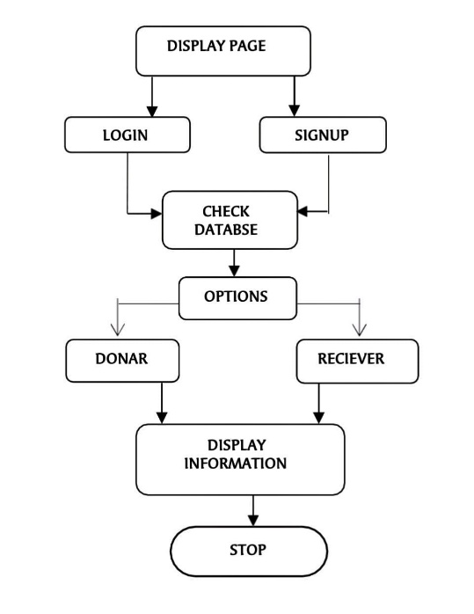

Fig 4. Blood-bank distribution network production map

The means are additionally clarified pictorially with the

assistance of stream diagram in Fig. 4

This has been seen that the enlistment and gift framework exceptionally influence the whole procedure however just little level of the requests are committed to expand these highlights. There is necessity of progressively reasonable investigation and further examinations for this stage. The administration of benefactor's database remarkably affects the effectiveness of the whole procedure and their motivation. The exhibition of the framework might be improved by expanding the quantity of gifts. Be that as it may, a viable administration of the enlisted benefactor's database is required. Capacity is additionally a significant phase of this procedure. A powerful stockpiling administration framework must guarantee a sufficient coordinating between the blood to hold/move. It assists with putting away blood in ideal conditions and abstain from terminating and releasing. The new blood donation center models are periodically based on evaluating the uniform stock amount for predicting and declining redundant packs and blood shortage. A structured approach to administration with blood details being taken care of can develop the ability.

1. **RESULTS**

Right now it has been put on application improvement for versatile gadgets like cell phones utilizing accessible programming. The technology generated is an attractive framework that is beneficial in apps for clients with poor gadget power. This program is eligible for download in any version beyond 4.1 (Jellybean). The most desirable requirements of the planned specification are -

Expanded commitment and communications: This ready to assist the client with accessing the application so effectively which does excludes any pop-ups, standards and so forth.

Around the same moment, consumers will come in on their own errand and can see the entire year of trade results.

Moment Access: This doesn't take a lot of time for the device to launch and carry its business out. This can be gotten to in a split second.

Expanded compliance for current frameworks: All information is maintained in a database that verifies records and can be accessed for no question over the months hard and quick.

Expanded compliance for current frameworks: All information is maintained in a database that verifies records and can be accessed for no question over the months hard and quick.

Progressively effective business process: Mobile applications offer speedy data and moment backing to clients constantly and wherever they required. All the main details can only be reached a tick away on their mobile phone. For eg, various technological developments may even be sent to their mobile phones if new details or notifications are accessible

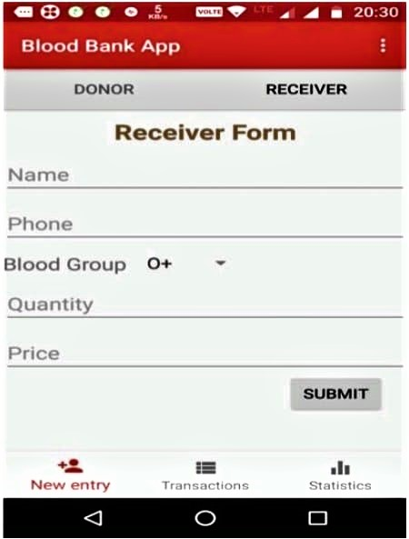The sum of blood was administered / gotten to the customer. Such research will improve the utility of the existing blood donation centers and help transition the standard setup to an increasingly beneficial and customer-friendly program.

Fig 5. Snapshot of Reciever form

# ACKNOWLEDGEMENT

Right now, I have made endeavors. Nonetheless, it would not have been possible without the charitable support and help of various citizens and organizations. I every wish to extend my sincere appreciation to each one of them. I am especially indebted to Prof. Laxmi J for her advice and steady oversight, even as I am indebted to provide critical data concerning the undertaking and also for their support in completing the mission. Likewise, my thanks go to my partner in building up the task and the people who enthusiastically got me out with their capacities.

**REFERENCES**

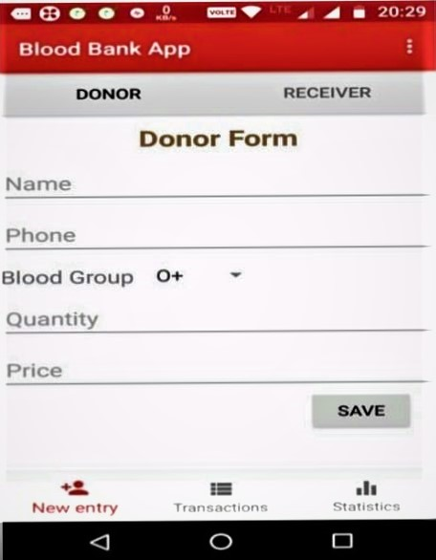

Fig 6. Snapshot of Donor Form

# CONCLUSIONS

The proposed Android Application is easy to understand and simple to use when contrasted with existing blood donation center applications. In existing interfaces their insights shows what number of units of required blood bunch are accessible. The reports area shows the month wherein blood bunch are being appropriated and gotten. Right now name enrollment,

1. Vikas Kulshreshtha and Sharad Maheshwari, “Benefits of Management Information System in Blood Bank”, International Journal of Engineering and Science, Vol. 1, Issue 12, PP 05-07, 2012.
2. Hayes, Helen and Onkar Sharma, "A decade of experience with a common first year program for computer science, information systems and information technology majors". Journal of Computing Sciences in Colleges, Vol. 18, No. 3 pp. 217–227, 2003.
3. Polack, Jennifer, "Planning a CIS Education Within a CS Framework". Journal of Computing Sciences in Colleges, Vol. 25, No. 2, pp. 100–106, 2009.
4. J. Scott Armstrong, "The Value of Formal Planning for Strategic Decisions: A Reply". Strategic Management Journal, Vol. 7, pp. 183–185, 1986.
5. Sayali Dhond, Pradnya Randhavan, Bhagyashali Munde, Rajnandini Patil, and Vikas Patil, “Android Based Health Application in Cloud Computing For Blood Bank”, International Engineering Research Journal (IERJ) Volume 1 Issue,2015.
6. T.Hilda Jenipha and R.Backiyalakshmi, “Android Blood Donor Life Saving Application in Cloud Computing”, American Journal of Engineering Research (AJER), Volume 03, Issue 02, pp. 105-108, 2014.
7. P. Priya, V. Saranya, S. Shabana and Kavitha Subramani,

telephone no and blood bunches should be given are incorporated. It likewise incorporates the blood amount to be put away in the application database. This can be called as new section as a client may enter his/her subtleties in the database. While in the recipient's structure this has person's name, telephone no (which a client can contact), their blood bunches should be gotten and the aggregate sum of amount. In the wake of presenting these information in the database, these fields are noticeable during exchange process. This shows how much

“The optimization of Blood Donor Information and Management System by Technopedia,” International Journal of Innovative Research in Science, Engineering and Technology, Volume 3, Special Issue 1, 2014.

1. Sultan Turhan, “An Android Application for Volunteer Blood Donors”, Computer Science & Information Technology- CSCP, pp. 23–30, 2015.
2. Catassi, C. A., Petersen, E. L. “The Blood Inventory Control SystemHelping Blood Bank Management Through Computerized Inventory Control”, Transfusion, Vol. 7, No. 60, 1967.
3. Arvind Sharma and P.C. Gupta, “Predicting the Number of Blood Donors through their Age and Blood Group by using Data Mining Tool”, International Journal of Communication and Computer Technologies, Volume 01, No.6, Issue 02, 2012.
4. PJ Saberton, Antonio Paez, K Bruce Newbold and Nancy M Heddle, “Geographical variations in the correlates of blood

donor turnout rates: An investigation of Canadian metropolitan areas”, International Journal of Health Geographics, Vol. 8, No.56,2009.

1. T. Santhanm and Shyam Sunderam, “Application of Cart Algorithm in Blood donor’s classification”, Journal of computer Science Vol. 6, Issue 5, 2010.
2. Premasudha, B.G., “Application of Spatial Decision Support System to Blood Bank Information Systems”, International Journal of Geoinformarics, Vol.6, No. 2, pp. 51,58,2010.